Install Istio using the demo profile, without any gateways:

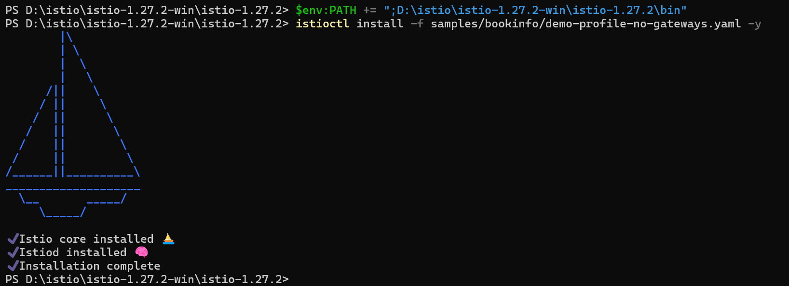

Add a namespace label to instruct Istio to automatically inject Envoy sidecar proxies when you deploy your application later:



Deploy the Bookinfo sample application:

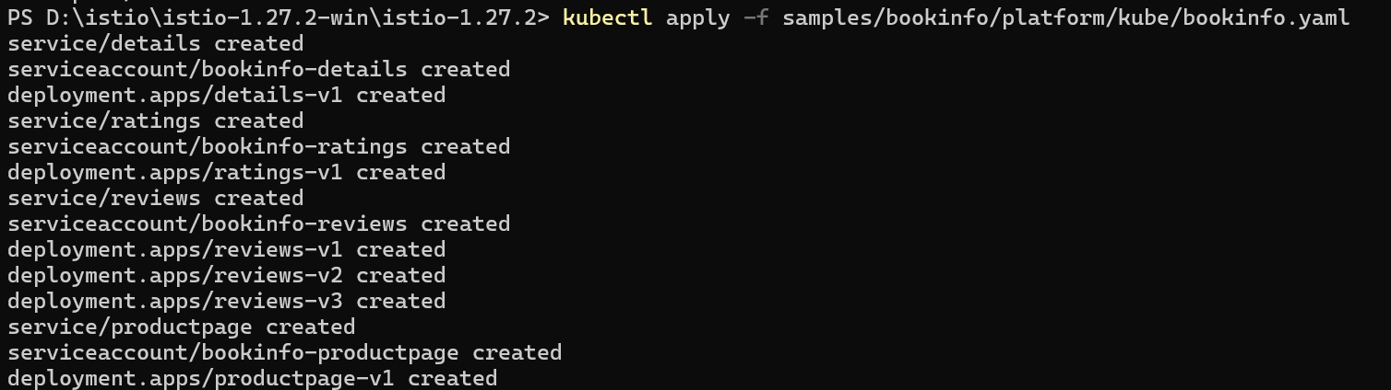

See each pod becomes ready, the Istio sidecar will be deployed along with it

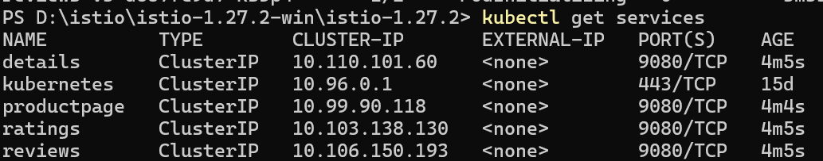

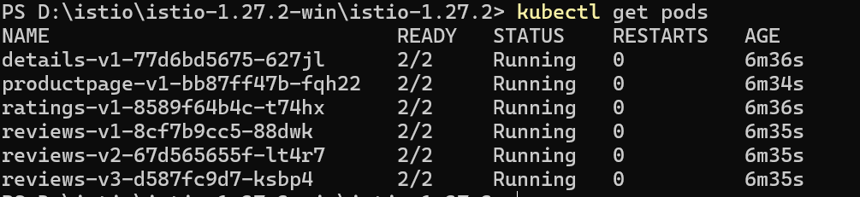

Create a Kubernetes Gateway for the Bookinfo application:



Change the service type to ClusterIP by annotating the gateway:



heck the status of the gateway



 connect to the Bookinfo productpage service through the gateway just provisioned



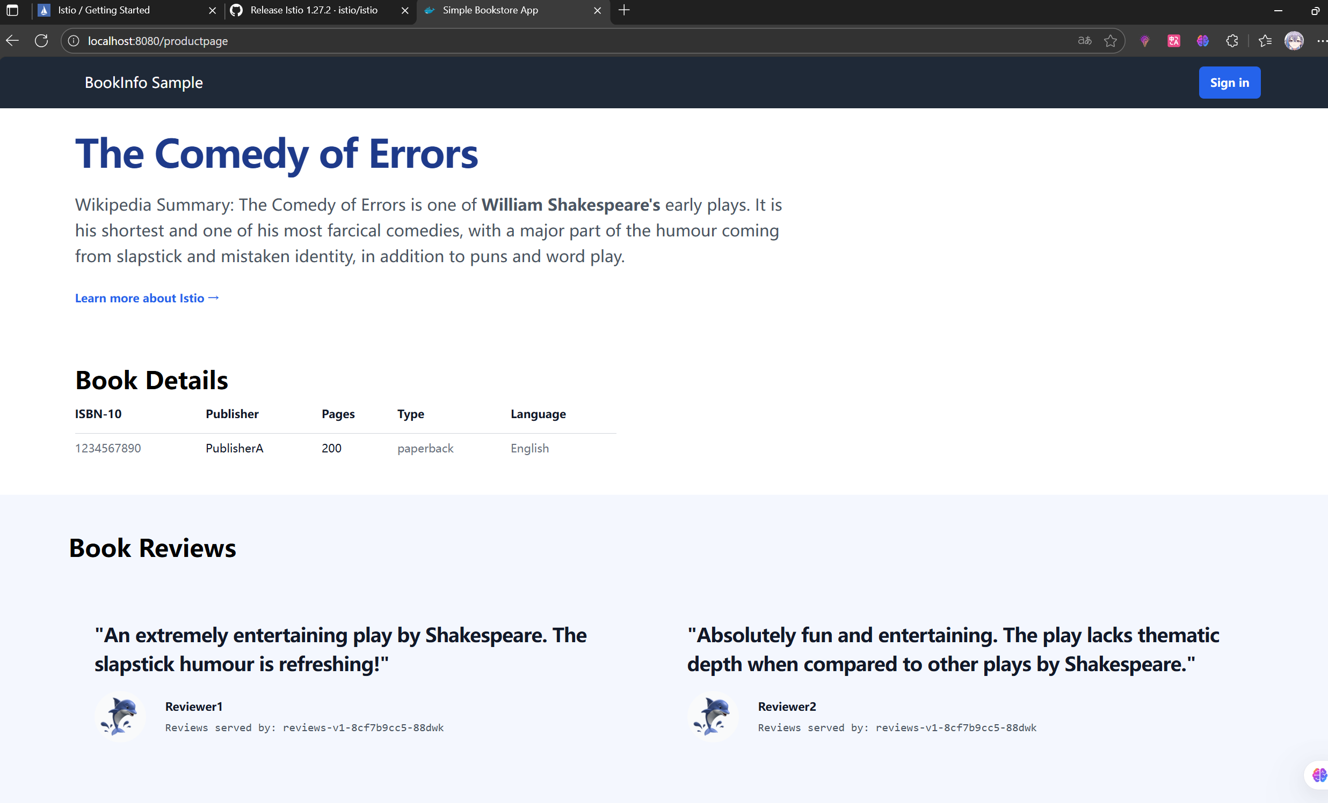

**View the dashboard**

Install Kiali and the other addons and wait for them to be deployed.

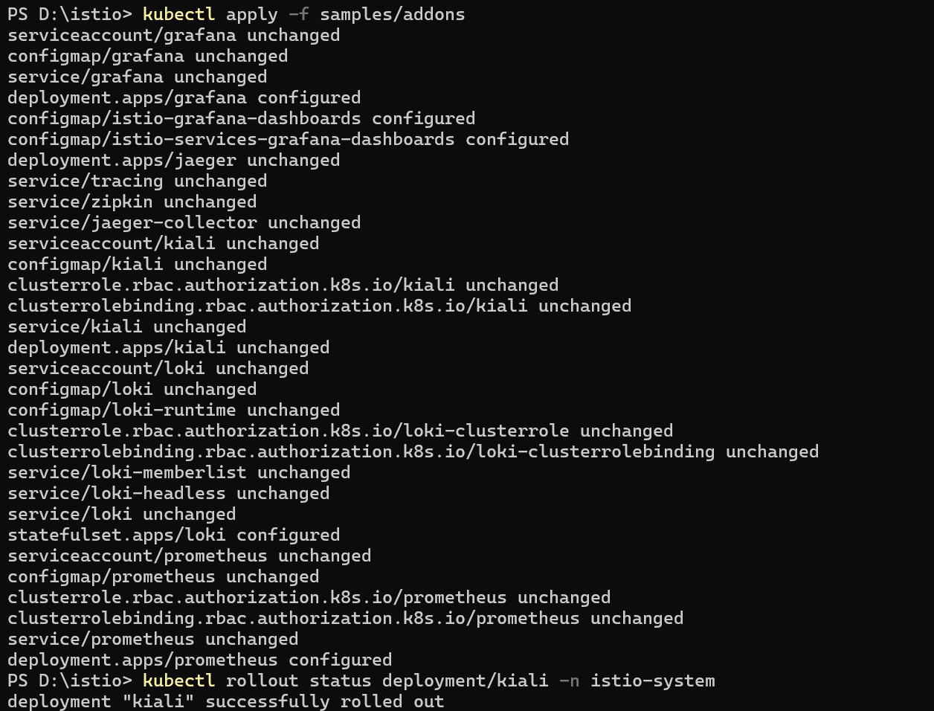

Access the Kiali dashboard



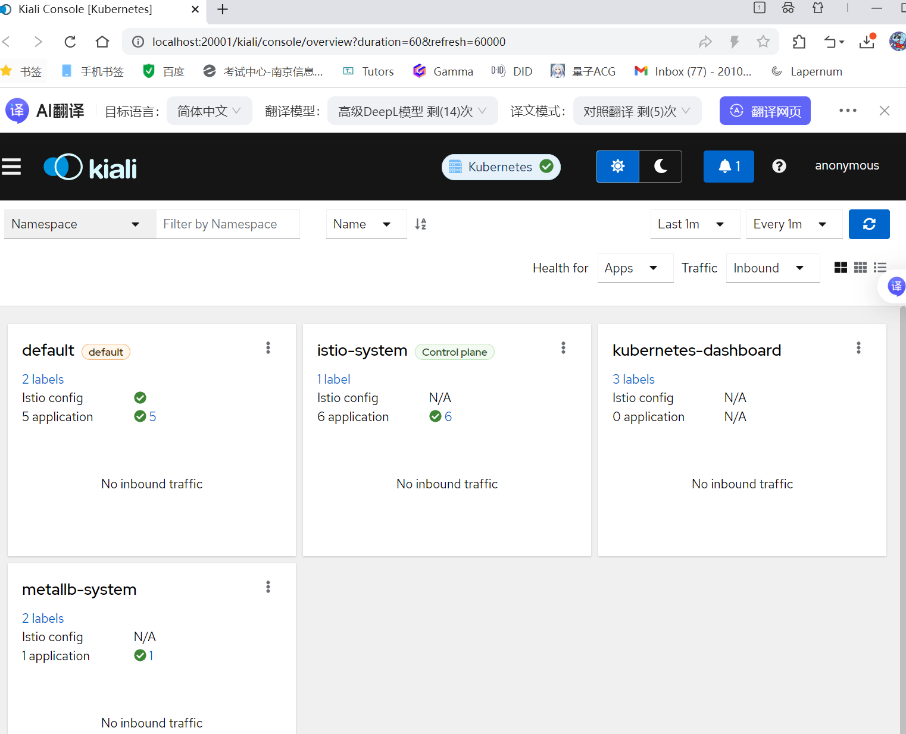

In the left navigation menu, select *Graph* and in the *Namespace* drop down, select *default*.

